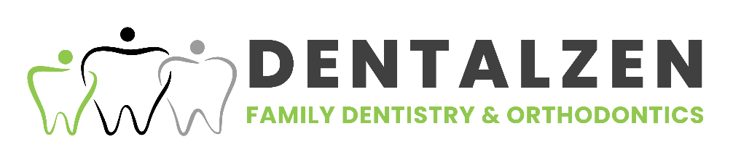

CONSENT

I consent to the collection, of any and all personal information about me including my personal health information about any minor or whom I have joint or sole custody, and to use such information in any manner or for any purpose whatsoever, but only in the course, of, concerning, or relating to, your dental practice. I similarly consent to the disclosure to third parties of all such information but only in accordance with the Regulated Health Professions, in the Dentistry, and Dental Hygiene Acts of Ontario, and to any insurer or other payment organization who may be responsible for payment of all are part of my treatment or service you provide.

______________________________ __________________________

Patient/Parent/Guardian Signature Date